Meet August’s Featured Fellowship Recipient!
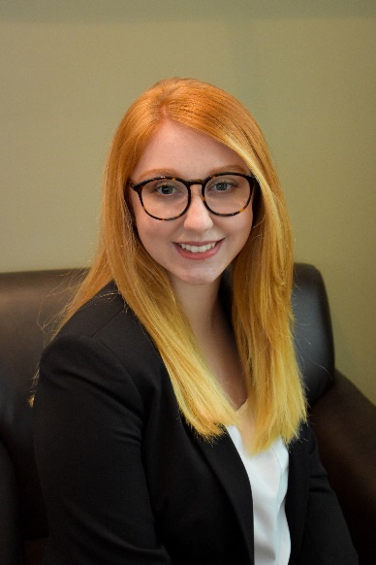
Kenzie Pehsoff, 5th Year Neuroscience & Cancer Biology PhD Student
Fellowship: NIH F31 (NINDS Institute), “Understanding the role of triggering receptor on myeloid cells 2 (TREM2) on microglia and macrophages across glioma progression”
Opportunity Details: PA-25-422: Ruth L. Kirschstein National Research Service Award (NRSA) Individual Predoctoral Fellowship (Parent F31) The F31 is an NIH fellowship aimed at supporting PhD candidates conducting dissertation research in biomedical sciences.
Choosing a Fellowship & Topic
Kenzie knew she planned to pursue a postdoc position, so she was eligible for both the F31 and F99/K00 NIH grants. She chose the F31 as it gave her more flexibility in selecting a post-doctoral research topic should she choose to change her focus area after graduation.
Her fellowship explores how TREM2 expression in different cell types and locations contributes to the development and maintenance of gliomas. This research will identify which genetic subtypes of cancer may respond to TREM2 modulation, and which cell populations may be most attractive to target.

Challenges & Advice for Applicants
Kenzie found the scope and grantsmanship requirements of the F Award to be the most challenging parts of her submission. At over 80 pages, NIH fellowship submissions are a herculean effort. She recommends speaking with senior students with an F31 to clarify instructions and content. “Don’t be afraid to ask to read someone’s grant! It’s helpful to see the components of a successful application then place your own research in that context.”
“My advice is to tailor every part of the application to the funding opportunity. You could be doing great research, but if it doesn’t meet the goals of the fellowship or the priorities of the institute, your grant will not score well. Use each sentence of your application to convince reviewers that your project is significant, feasible, and will contribute to your development as a scientist.”
Impact on Her Career
Kenzie is excited for the opportunities that will be available to her with a successful fellowship application on her academic record.
“Establishing a record of securing independent funding early in my career helps me be competitive for future opportunities. Publications and grants are the currency of academia, so the sooner you’re in the cycle of getting one to fuel the other, the better!”

- How did you select which fellowship to apply for?
When I was deciding which opportunities to aim for, I narrowed down my options to the F31 and F99/K00. I applied at the end of my third year and knew I planned to pursue a postdoc, so I was eligible for both. Ultimately, I chose the F31 because I didn’t want my postdoctoral research direction to be restricted by my current project.
Kenzie knew she planned to pursue a postdoc position, so she was eligible for both the F31 and F99/K00 NIH grants. She chose the F31 as it gave her more flexibility in selecting a post-doctoral research topic should she choose to change her focus area after graduation.
- What is the central question your research aims to address, and why is it important in the field of biomedical science?
TREM2 is a receptor involved in balancing inflammation in both neurodegeneration and cancer, but its role in brain tumors is controversial. My previous paper described an anti-glioma function of TREM2, while others have found TREM2 promotes glioma progression. My grant aims to resolve these findings by exploring how TREM2 expression by brain-resident versus peripherally-derived myeloid cells contributes to the development and maintenance of gliomas with distinct driver mutations. This research will help to understand what genetic subtypes of brain cancer may be susceptible to TREM2-modulating strategies, particularly which disease stages and cell populations are most attractive to target.
Her fellowship explores how TREM2 expression in different cell types and locations contributes to the development and maintenance of gliomas. This research will identify which genetic subtypes of cancer may respond to TREM2 modulation, and which cell populations may be most attractive to target.

- What was the most challenging part of preparing your fellowship application, and how did you overcome it?

Kenzie found the scope and grantsmanship requirements of the F Award to be the most challenging parts of her submission. At over 80 pages, NIH fellowship submissions are a herculean effort. She recommends speaking with senior students with an F31 to clarify instructions and content. “Don’t be afraid to ask to read someone’s grant! It’s helpful to see the components of a successful application then place your own research in that context.”

Learning all the NIH jargon was daunting. There are also a lot of administrative documents that must be submitted for your fellowship to be complete—mine ended up at over 80 pages in the end. Talking to senior students with an F31 was the best way for me to clarify everything. Don’t be afraid to ask to read someone’s grant! It’s helpful to see the components of a successful application then place your own research in that context.”

- What’s the most important piece of advice you’d give to someone just starting to prepare their own fellowship application?
“My advice is to tailor every part of the application to the funding opportunity. You could be doing great research, but if it doesn’t meet the goals of the fellowship or the priorities of the institute, your grant will not score well. Use each sentence of your application to convince reviewers that your project is significant, feasible, and will contribute to your development as a scientist.”

- Can you share a moment when you felt especially supported by your peers, mentors, or the GSBS while completing your application?
- Have you learned anything about yourself through the fellowship process?
- How do you hope receiving this fellowship will shape your long-term goals in biomedical research?
Kenzie is excited for the opportunities that will be available to her with a successful fellowship application on her academic record. “Establishing a record of securing independent funding early in my career helps me be competitive for future opportunities. Publications and grants are the currency of academia, so the sooner you’re in the cycle of getting one to fuel the other, the better!”
I hope that establishing a record of securing independent funding early in my career helps me be competitive for future opportunities. Publications and grants are the currency of academia, so the sooner you’re in the cycle of getting one to fuel the other, the better!

Student: Kenzie Peshoff
Year in GSBS/Program: 5th year, Neuroscience and Cancer Biology
Fellowship: NIH F31
Project Title: Understanding the role of triggering receptor on myeloid cells 2 (TREM2) on microglia and macrophages across glioma progression
Summary About Fellowship (1 sentence): The F31 is an NIH fellowship aimed at supporting PhD candidates conducting dissertation research in biomedical science.
Institute (If F30/31): NINDS
Link to Fellowship: PA-25-422: Ruth L. Kirschstein National Research Service Award (NRSA) Individual Predoctoral Fellowship (Parent F31)

